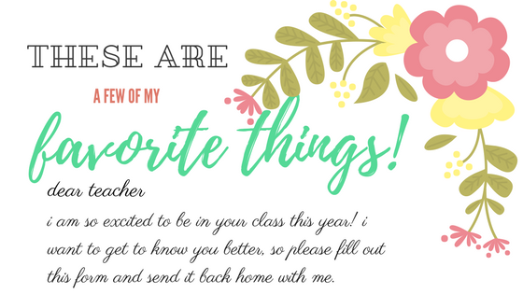

Name & birthday:

Candy, snacks or drinks:

Places to eat or shop:

Activities or hobbies:

Favorite ways to relax or pamper yourself:

Favorite gifts to receive:

Not so favorite gifts to receive:

Favorite teaching item or school supplies to receive:

Favorite scent, lotion or candle:

It means the most to me when the parents of my students:

